Title: **Voltage Dividers** Test: 7

Course: Electrical Applications Unit: Electrical Theory CLO: 3

Name ____________________________ Grade _______ Date ______________

**Objectives**

1. Student shall identify different electrical characteristics as they pertain to voltage dividers.
2. Student shall calculate various electrical quantities for a voltage divider based on the Ohm’s Wheel.

**Assessment**

Students shall demonstrate a comprehension of the objectives listed above by scoring a minimum of 75% on this Test. Grading shall be based on an answer key.

**Circuit**

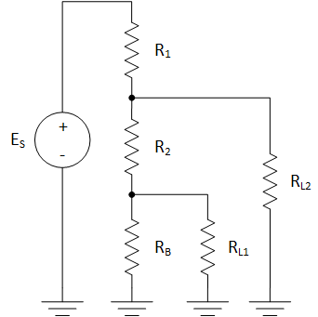

Where;

$$E_{S}=65V, E_{L1}=10V, E_{L2}=27V, I_{L1}=27mA, I_{L2}=75mA$$

**Instructions**

Complete the table below based on the voltage divider circuit and given quantities above.

|  |  |  |  |  |
| --- | --- | --- | --- | --- |
|  | P | I | R | E |
| R1 |  |  |  |  |
| R2 |  |  |  |  |
| RB |  |  |  |  |
| RL1 |  |  |  |  |
| RL2 |  |  |  |  |
| Total |  |  |  |  |

1. What would be the effect of increasing the value of R2 on EL2?
   1. Go Up
   2. Go Down
   3. Stayed the same

**Circuit**

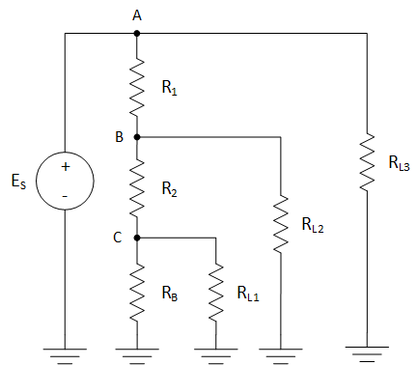

Where;

$$E_{S}=50V, E_{L1}=15V, E_{L2}=24V, P_{L1}=2W, P_{L2}=15W, P_{L3}=11W$$

**Instructions**

Complete the table below based on the voltage divider circuit and given quantities above.

|  |  |  |  |  |
| --- | --- | --- | --- | --- |
|  | P | I | R | E |
| R1 |  |  |  |  |
| R2 |  |  |  |  |
| RB |  |  |  |  |
| RL1 |  |  |  |  |
| RL2 |  |  |  |  |
| RL3 |  |  |  |  |
| Total |  |  |  |  |

1. What would be the effect of increasing the value of RL3 on IT?
   1. Go Up
   2. Go Down
   3. Stayed the same
2. What would be the effect of increasing the value of RL3 on IB?
3. Go Up
4. Go Down
5. Stayed the same
6. What would be the effect of increasing the value of RB on EL1?
7. Go Up
8. Go Down
9. Stayed the same
10. The sum of the individual component power values in this circuit will equal ES x IT?
11. True
12. False